Shubham Jain

A00258743 | Group B

JDBC PROJECT

DataBAses

# Brief

The main aim of this project is to showcase database skills such as JDBC, Stored Procedures, triggers, functions etc.

A Java project template provided has been used and altered to display required data model which has working CRUD operations as well as 4 working filters that export data to excel.

# Scope

The scope of this project is limited to mysql queries and functionalities. More work is done on back-end rather than front end.

# File Structure

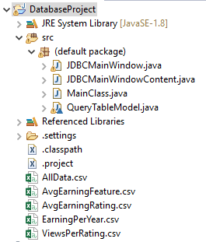

--Exported CSV Files

--Java Classes

# Database Structure

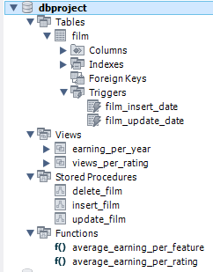

Table Features

* Most suitable datatypes with default values are used
* primary key is auto-Incremented
* last_update column has a trigger for Inserting/Updating values

SQL

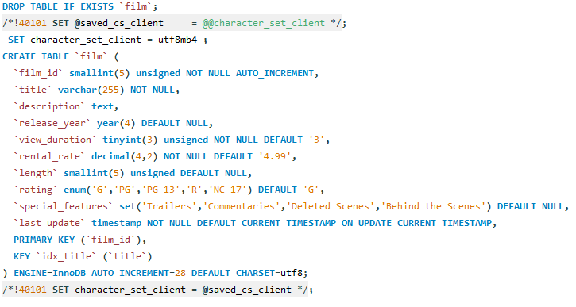

TRIGGERS

* Triggers are used to update a column whenever Insert/Update is executed.
* It updates current time in the column.

**Sql**

Before Insert



Before Update

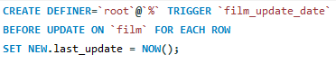

PROCEDURES

* Stored Procedures are used in this project from Insert, Update and Delete operations.

**Sql**

Insert

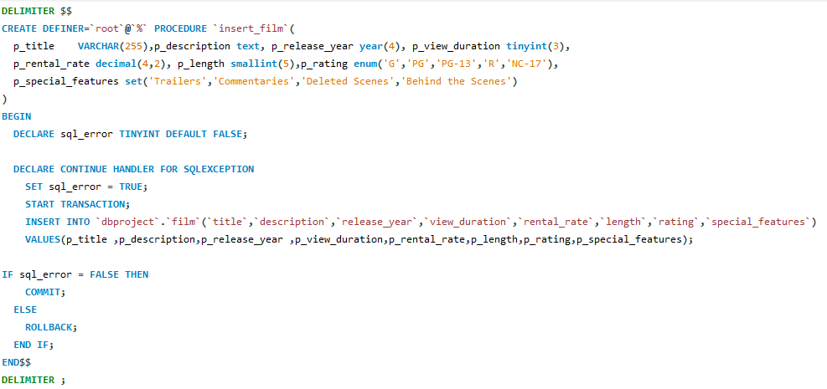

Update

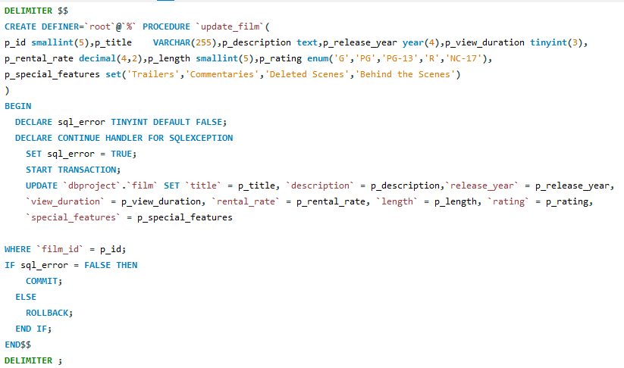

Delete

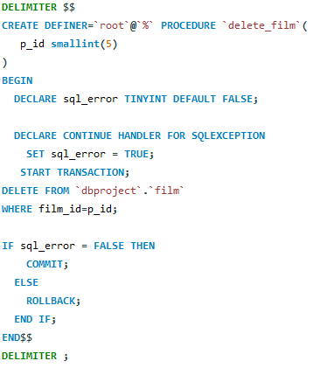

VIEWS

* Views have been used to export data which have queries with no parameters

**Sql**

1. Earning Per Year

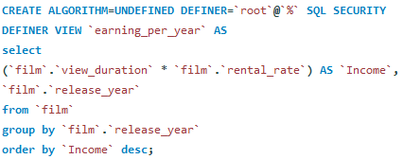

Excel OutPut

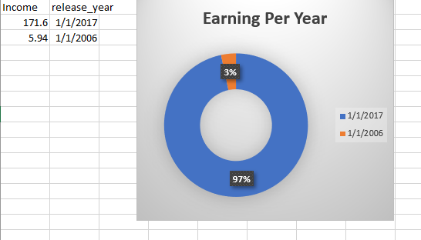

1. Views Per Rating Type

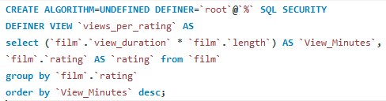

Excel OutPut

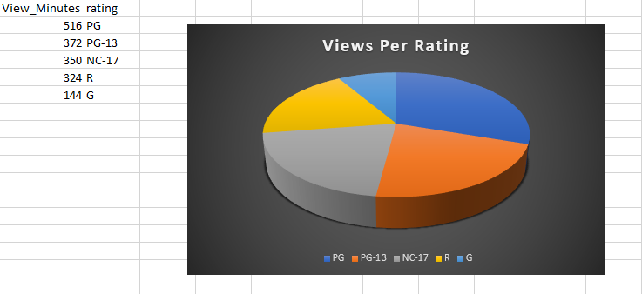

Functions

* Functions have been used to export data for queries with parameters

**Sql**

1. Average Earning Rating Wise

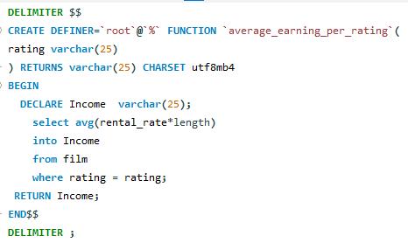

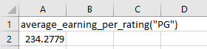

1. Average Earning Feature Wise

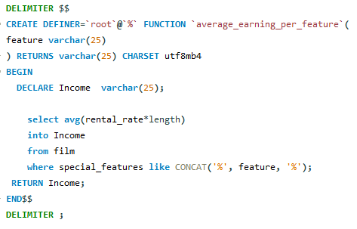

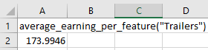

# GUI

On Clicling a row from Jtable all values get automatically populated, ready for CRUD operations.

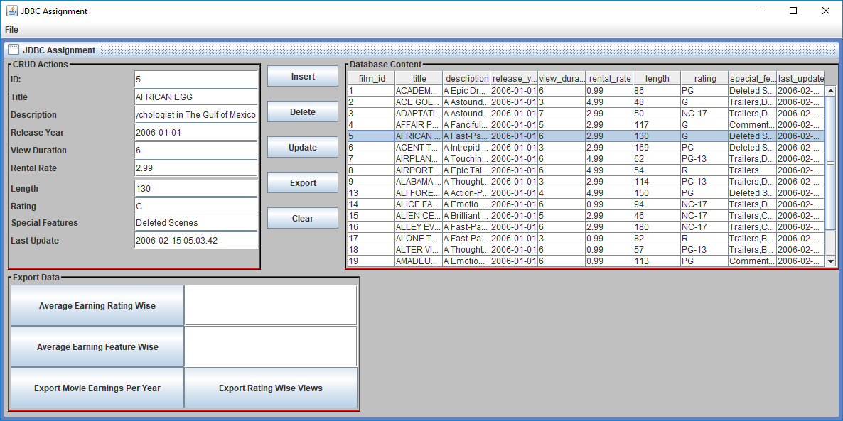

# Conclusion

Thus this project contains all the back-end featured which are advanced and required for this JDBC project.